UNITED STATES
SECURITIES AND EXCHANGE COMMISSION
Washington, D.C. 20549
SCHEDULE 14A
PROXY STATEMENT PURSUANT TO SECTION 14(a)
OF THE SECURITIES EXCHANGE ACT OF 1934
Filed by the Registrant x Filed by a Party other than the Registrant o
Check the appropriate box:

o |  |  |  |  |  | Preliminary Proxy Statement
o |  |  |  |  |  | Confidential, for Use of the Commission Only (as permitted by Rule 14a-6(e)(2))
o |  |  |  |  |  | Definitive Proxy Statement
x |  |  |  |  |  | Definitive Additional Materials
o |  |  |  |  |  | Soliciting Material Pursuant to §240.14a-11(c) or §240.14a-12
Sphere 3D Corp.
(Name of Registrant as Specified in its Charter)
(Name of Person(s) Filing Proxy Statement, if other than the Registrant)
Payment of Filing Fee (Check all boxes that apply):
x |  |  |  |  |  | No fee required
o |  |  |  |  |  | Fee paid previously with preliminary materials
o |  |  |  |  |  | Fee computed on table in exhibit required by Item 25(b) per Exchange Act Rules 14a-6(i)(1) and 0-11


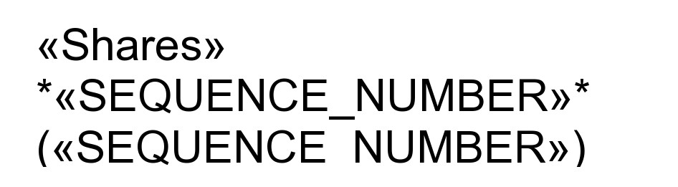
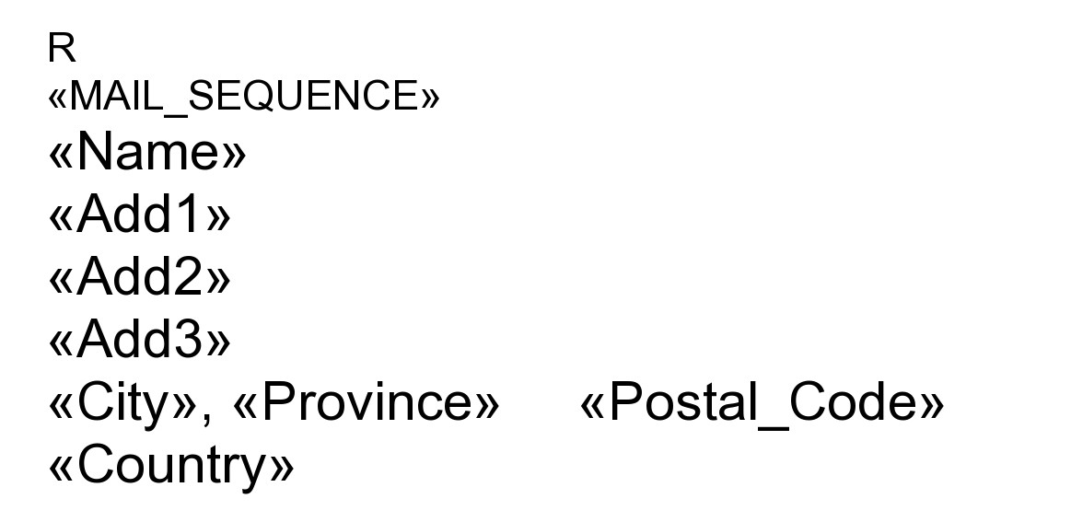


IMPORTANT NOTICE REGARDING
INTERNET AVAILABILITY OF PROXY MATERIALS
for the Sphere 3D Corp.
Special Meeting of Shareholders

Meeting Details
Monday, August 24, 2026
1:00 PM Eastern Time
https://Virtual-Meetings.TSXTrust.com/1955
Password: sphere3d2026 (case sensitive)
Get Informed Before You Vote
View the Notice of Meeting and Proxy Statement online at HTTPS://DOCS.TSXTRUST.COM/2040
OR
You can receive a free paper or email copy of the materials by requesting prior to August 17, 2026. Unless requested, you will not receive a paper or email copy. If you would like to request a copy of the materials for this and/or future shareholder meetings, you may call 1-800-600-5869 or Email TSXTIS@TMX.COM. Please be sure to include your Control Number (as shown above) in your Email.
Your Vote Counts
You may enter your voting instructions at www.VoteProxyOnline.com
Using your Control Number above
Until 1:00 PM Eastern Time August 21, 2026

Vote In Person at the Meeting
Visit https://Virtual-Meetings.TSXTrust.com/1955
Enter Password: sphere3d2026 (case sensitive)
Enter Your Control Number (shown above)

If you are a non-registered shareholder and want to vote online at the Meeting, you must appoint yourself as proxyholder prior to proxy cut-off and register with TSX Trust in advance of the Meeting prior to proxy cut-off by emailing tsxtrustproxyvoting@tmx.com the "Request for Control Number" form which can be found here https://www.tsxtrust.com/resource/en/75
Proposals Being Considered at the Meeting
See Proposals on the Reverse Side

THIS IS NOT A VOTABLE BALLOT

This is an overview of the proposals being presented at the upcoming shareholder meeting. Please follow the instructions on the reverse side to vote these important matters.

Voting Items
1.To approve the adoption of a special resolution authorizing the Company to make an application for the continuance of the Company from the laws of the Province of Ontario to the laws of the Province of British Columbia and approving the notice of articles and articles of the continued company.
2.To approve a potential name change of the Company.
3.To approve adjournments or postponements of the meeting or to transact such other business as may be properly brought before the meeting.

THE BOARD OF DIRECTORS RECOMMENDS THAT YOU VOTE “FOR” ALL PROPOSALS ABOVE

PLEASE NOTE – THIS IS NOT A PROXY CARD

YOU CANNOT VOTE BY RETURNING THIS CARD

